**Project Design Phase-II**

# CUSTOMER JOURNEY MAP

|  |  |
| --- | --- |
| Date | 19 October 2022 |
| Team ID | PNT2022TMID26770 |
| Project Name | Natural Disasters Intensity Analysis and Classification using Artificial Intelligence |
| Maximum Marks | 4 Marks |

## Step-1 : Entice

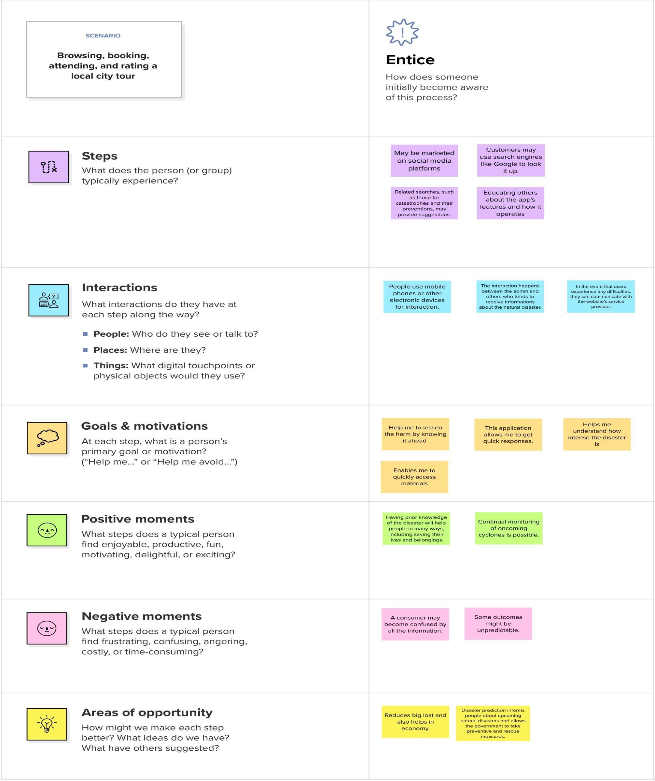

## Step-2 : Enter

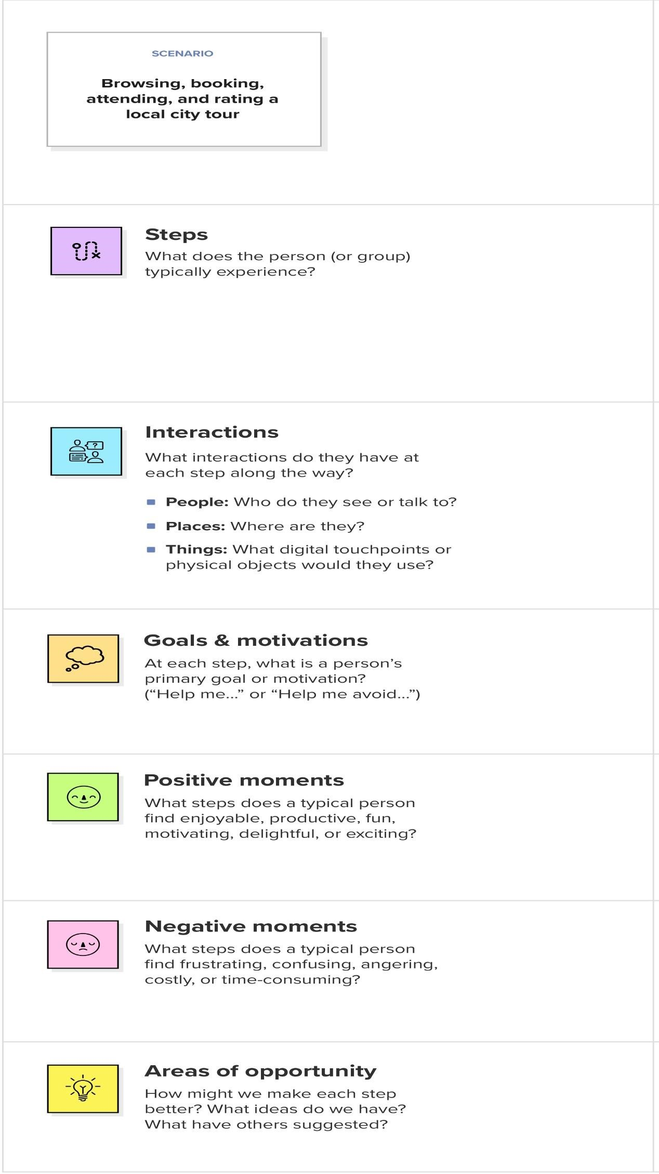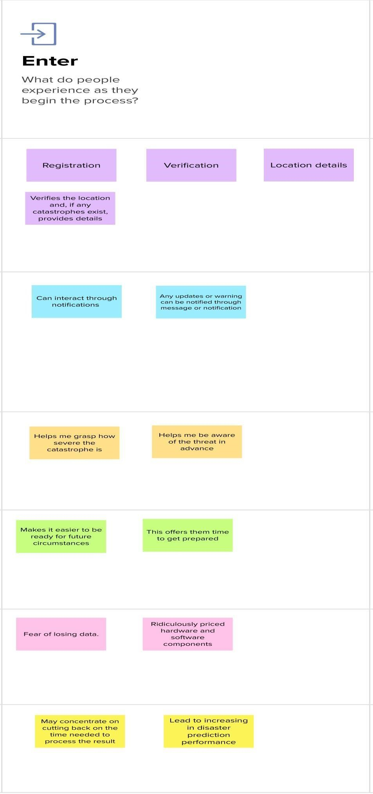

## Step-3 : Engage

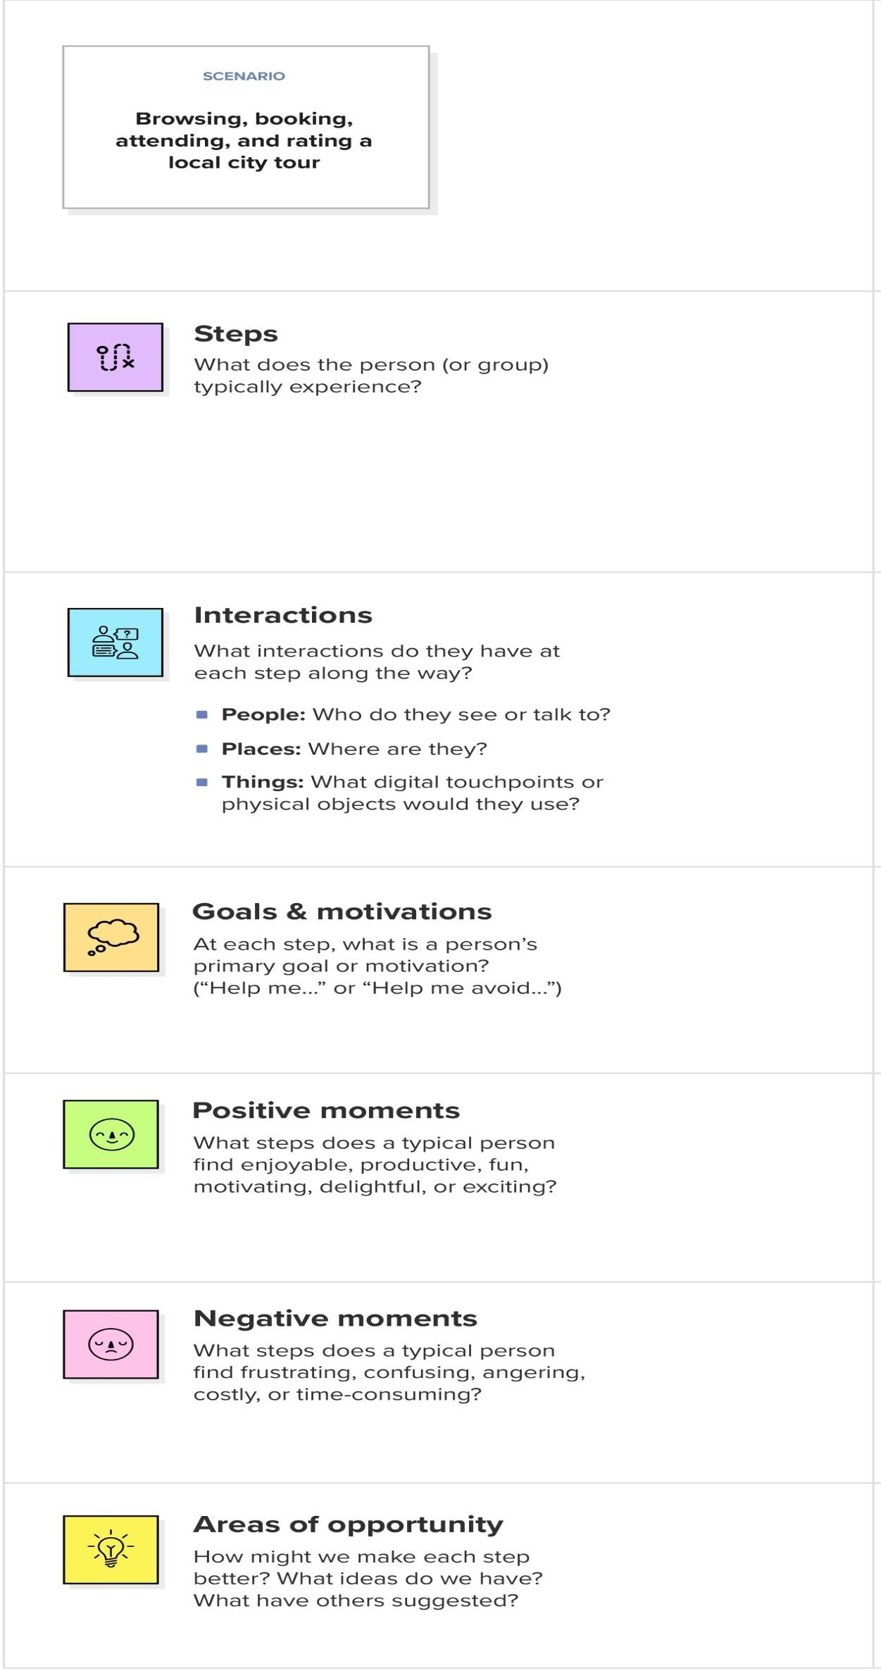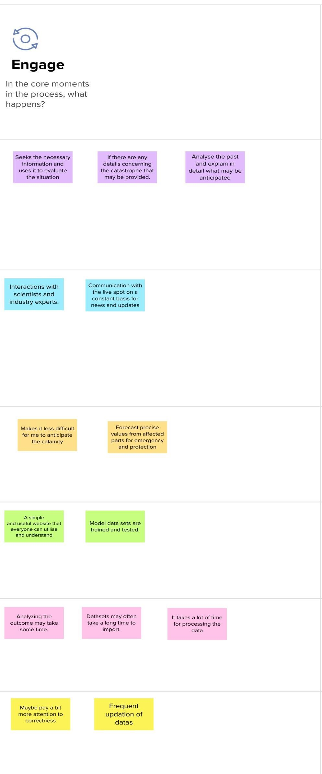

## Step-4 : Exit

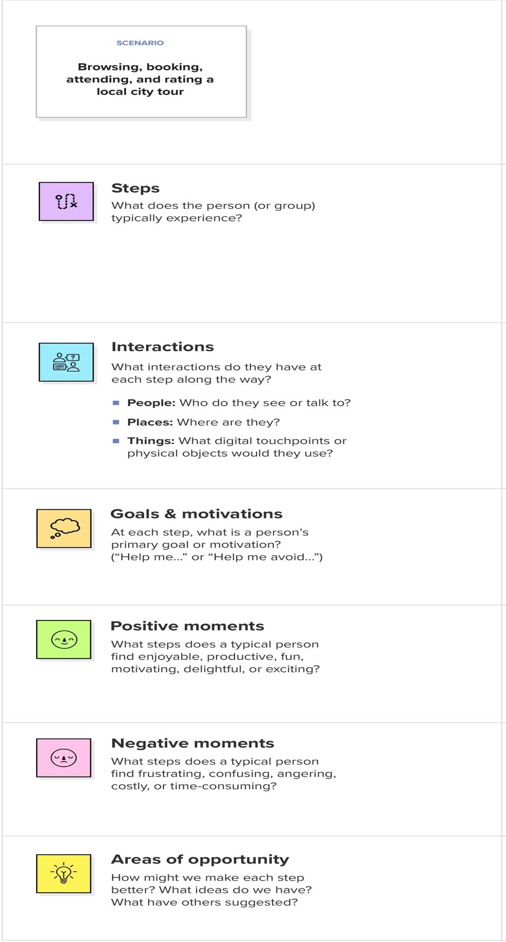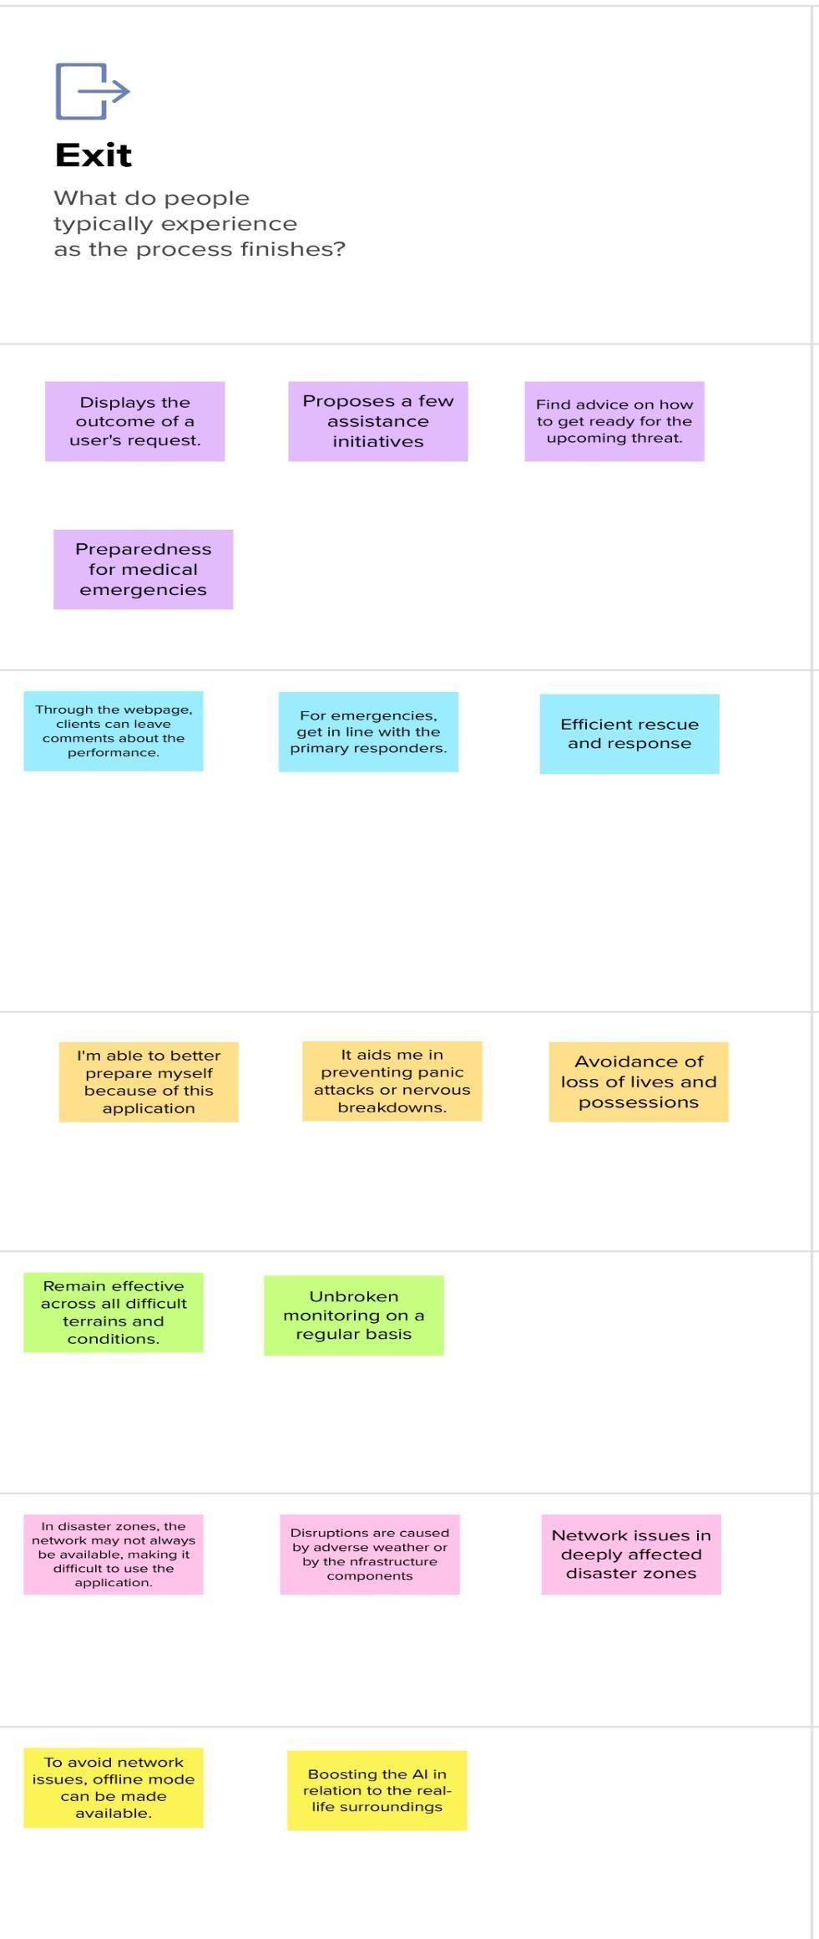

## Step-5 : Extend

